BIOINFORMATICS
WEEK 1 - DAY 1 NOTES

BIOINFORMATICS is an interdisciplinary field that uses computer technology, mathematics, and statistics to collect, store, organize, analyze, and interpret large volumes of biological data. It essentially acts as a bridge between computer science and biology, allowing scientists to make sense of the massive datasets generated by modern laboratory techniques like DNA sequencing.

WHY IS BIOINFORMATICS IMPORTANT?
Modern biology generates enormous amounts of data analyzing these datasets would be nearly impossible without Bioinformatics.
Some examples:
- Human Genome Project
- COVID-19 genome sequencing
- Cancer mutation studies
- Drug discovery
- Personalized medicine
- Agricultural crop improvement
- Evolutionary studies

WHERE IS BIOINFORMATICS USED?
Field | Example
Medicine | Finding disease-causing mutations
Drug Discovery | Identifying potential drug targets
Agriculture | Developing drought-resistant crops
Forensics | DNA fingerprinting
Evolution | Comparing species
Biotechnology | Protein engineering
Diagnostics | Pathogen identification

- Paulien Hogeweg and Ben Hesper coined the term Bioinformatics in 1970 to refer to the study of information processes in biotic systems.

ORIGIN & HISTORY OF BIOINFORMATICS

1. Ancient/Traditional Era (≈6000 BCE–1800s)
- ~6000 BCE: Beer and wine production by the Sumerians and Egyptians using natural fermentation—among the earliest documented applications of biotechnology.
- ~4000 BCE: Bread-making using yeast and the production of cheese and yogurt through bacterial fermentation.
- Ancient civilizations: Selective breeding of crops and livestock to enhance desirable traits—an early form of genetic improvement practiced without knowledge of genes or DNA.

2. Scientific Foundation Era (1850s–1940s)
- 1857–1864: Louis Pasteur demonstrates that fermentation is carried out by microorganisms, establishing the scientific basis of industrial fermentation.
- 1866: Gregor Mendel publishes his laws of inheritance, laying the foundation of modern genetics (his work is rediscovered in 1900).
- 1919: Karl Ereky, a Hungarian engineer, coins the term "biotechnology", describing the use of living organisms to convert raw materials into useful products.
- 1928: Alexander Fleming discovers penicillin, leading to the development of industrial-scale antibiotic production during the 1940s.
- 1944: Oswald Avery, Colin MacLeod, and Maclyn McCarty demonstrate that DNA is the genetic material, paving the way for molecular biology.

3. Molecular Biology Era (1950s–1970s)
- 1953: James Watson and Francis Crick, using crucial X-ray diffraction data produced by Rosalind Franklin and Maurice Wilkins, describe the double-helix structure of DNA.
- 1970: Discovery of restriction enzymes (Werner Arber, Hamilton O. Smith, and Daniel Nathans), enabling scientists to cut DNA at specific sequences and making recombinant DNA technology possible.
- 1973: Stanley Cohen and Herbert Boyer create the first successful recombinant DNA molecules, marking the birth of modern genetic engineering.
- 1975: Georges Köhler and César Milstein develop monoclonal antibody technology, transforming diagnostics and therapeutic medicine.

4. Modern Biotechnology Era (1976–Present)
- 1976: Genentech is founded, becoming the first biotechnology company built around recombinant DNA technology.
- 1982: Humulin (recombinant human insulin) becomes the first genetically engineered drug approved by the U.S. FDA.
- 1990–2003: The Human Genome Project successfully sequences the complete human genome.
- 2012: Jennifer Doudna and Emmanuelle Charpentier develop CRISPR-Cas9 as a programmable genome-editing technology, revolutionizing genetic engineering.
- 2020s: mRNA vaccine technology gains widespread clinical validation through COVID-19 vaccines, while AI-powered protein structure prediction (e.g., Alpha Fold) accelerates biological research and drug discovery.

THE CENTRAL DOGMA OF MOLECULAR BIOLOGY
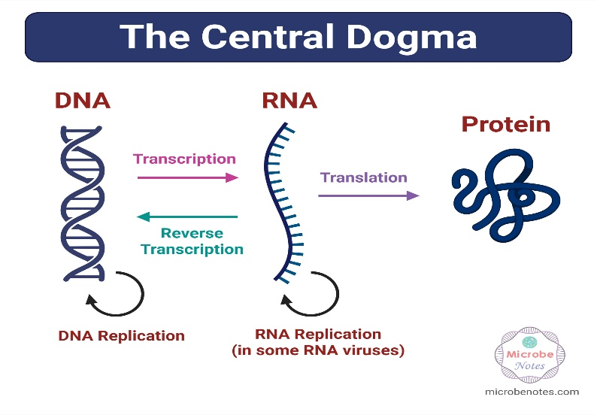

Key Terms

Genome - The complete DNA of an organism.
Example: The human genome contains approximately 3.2 billion base pairs.

Transcriptome - All RNA molecules expressed in a cell or tissue at a specific time.
The transcriptome changes depending on: Cell type, Environment, Disease, Developmental stage

Proteome - The complete set of proteins produced by a cell, tissue, or organism at a given time.

DNA vs RNA vs Protein
Feature | DNA | RNA | Protein
Function | Stores information | Carries information | Performs cellular functions
Building blocks | Nucleotides | Nucleotides | Amino acids
Bases | A, T, G, C | A, U, G, C | 20 amino acids
Usually double-stranded? | Yes | Usually no | No
Stability | High | Lower | Varies

BIOLOGICAL DATABASES

1. NCBI (National Center for Biotechnology Information) - This is one of the world's largest biological databases.
You'll use it to find:
- Gene information
- DNA sequences
- Protein sequences
- Research articles
- Genome assemblies
- BLAST

2. UniProt - UniProt focuses on proteins.
For a protein, you'll find:
- Function
- Structure
- Domains
- Cellular location
- Interactions
- Disease associations

3. EMBL-EBI - It hosts many databases and analysis tools.
use it later for:
- Sequence alignment
- Protein families
- Functional annotation

FIRST PRACTICAL EXERCISE
Choose the human insulin gene (INS).
- Find the gene page in NCBI.
- Download the DNA sequence in FASTA format.
- Find the corresponding protein entry.
- Download the protein sequence in FASTA format.
- Save them in a folder named:

Day1/
├── insulin_dna.fasta
└── insulin_protein.fasta

What is FASTA?
FASTA is a standard text format for storing sequences.
A FASTA file begins with a header line starting with > followed by the sequence.
Example: >Example DNA
ATGCGTACCGAT...
The header identifies the sequence.
The lines below contain the actual sequence.

FIRST PYTHON PROGRAM
Install: Python & VS Code
Create a file named: hello_bioinformatics.py
Write: print("Hello, Bioinformatics!")
Run it.
Then try: gene = "INS"
organism = "Homo sapiens"

print("Gene:", gene)
print("Organism:", organism)

